ISA Athlete of the Term
Nominee Autumn 2022

Congratulations to

Lord Lexden  President |  | 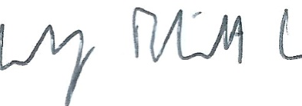  Rudi Elliot Lockart  CEO

