**18th ISA National Gymnastics Team Championships**

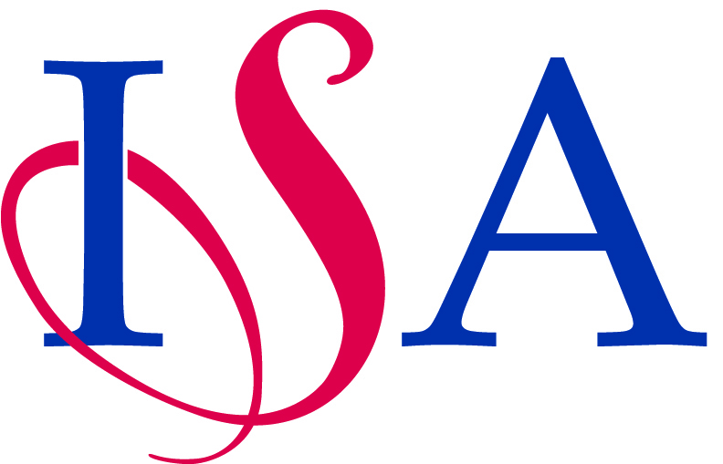

**Team Names Declaration Form**

**To be typed and not handwritten please**

|  |  |
| --- | --- |
| School Name |  |
| School Address |  |
| School Tel |  |
| Email |  |
| Teacher i/c |  |

|  |
| --- |
| Names of teachers / coaches for the printed programme: |
|  |
|  |
|  |
| Team colours |
| Girls |
| Boys |

|  |  |  |  |  |  |
| --- | --- | --- | --- | --- | --- |
|  | Girls Under 11 Names | Date of Birth |  | Girls Under 9 Names | Date of Birth |
| 1 |  |  | 1 |  |  |
| 2 |  |  | 2 |  |  |
| 3 |  |  | 3 |  |  |
| 4 |  |  | 4 |  |  |
| 5 |  |  | 5 |  |  |
| 6 |  |  | 6 |  |  |
|  |  |  |  |  |  |
|  | Boys Under 11 Names | Date of Birth |  | Boys Under 9 Names | Date of Birth |
| 1 |  |  | 1 |  |  |
| 2 |  |  | 2 |  |  |
| 3 |  |  | 3 |  |  |
| 4 |  |  | 4 |  |  |
| 5 |  |  | 5 |  |  |
| 6 |  |  | 6 |  |  |

a) An Under 9 competition for pupils U9 on 1st Sept of current academic year

b) An Under 11 competition for pupils U11 on 1st Sept of current academic year

eg. Girls with their 9th birthday on or after 1st September of the current academic year are under 9’s. Girls having their 10th or 11th birthdays on or after 1st September of the current academic year are Under 11’s and this is regardless of which year group their school has placed them in. Girls with their 12th birthday on or after 1st September of the current academic year are not eligible for the Under 11’s.

An U9 gymnast may compete in an U11 team with U11 rules but may not compete in two age group teams in the same academic year.

Names may be changed at a later date, but if so, they might not be included in the printed event programme if it has gone to press.

Email this form to both the Host Organiser: Louise Hudson,[**lhudson@adcoteschool.co.uk**](mailto:lhudson@adcoteschool.co.uk)

and Competition Secretary: June Walden, [**chairman@isgagymnastics.org**](mailto:chairman@isgagymnastics.org)

**No later than Friday 10 March 2023.** Thank you.