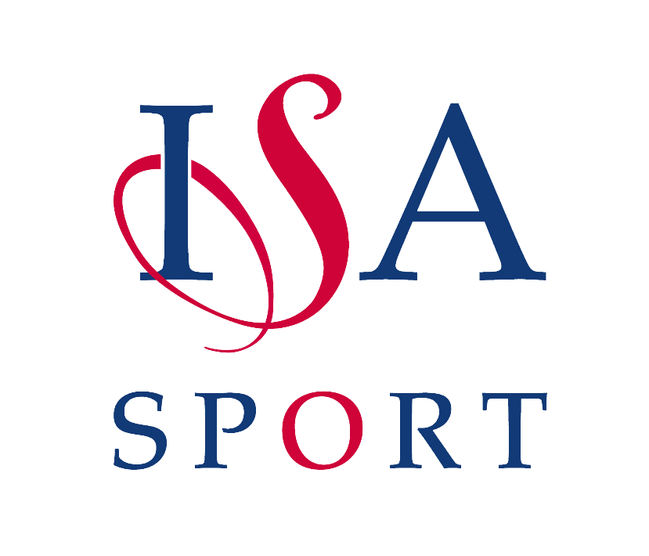

Congratulations to

_________________________________________

School: ________________ ISA Area: ________________

For Setting a New National Record in

_______________________________________

Awarded by:

The Independent Schools Association

Lord Lexden Emily Ward
ISA President ISA National Sports Officer

