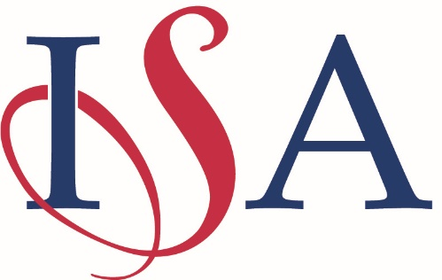

Disclaimer
Adcote School, The Independent Schools Association (ISA), and the Competition Organisers regret that they cannot accept legal liability for any damage or accident during any of the competitions. It is incumbent upon all teachers, coaches and parents to check with their school that they are adequately insured.

Adcote School, The Independent Schools Association (ISA), and the Competition Organisers regret that they cannot accept liability for loss or damage howsoever caused to the personal property of anyone attending this competition.

If any item is of significant value, schools and parents are advised to check the cover that may be in place under existing policies, for example, Household Insurance, and if in doubt, to effect specific insurance to cover the items in question for the duration of this event. It is suggested that this should cover travel to and from the venue.

I confirm that I have read and understood the above disclaimer and sign below to show my acceptance of the conditions. I understand that our entry to this event will only be accepted when this signed Disclaimer Form has been received by the Competition Secretary and Host Organiser.

Headmaster/Headmistress

School.……………………………………………………………………………………….……………………………………………………
(block capitals):
Address …………………………………………………………………………………………………………………………………………

Tel………………………………………………….. Email address ………………………………………………………………….

Head’s Name ………………………………………………………………………………………………………
(block capitals):

Head’s signature: ……………………………………………………………………

Date: ...…………….………………… Year ……………

Teacher / Coach

Name ……………………………………………………………………………………………………….……………………………….…
(block capitals):

Signature: …………………………………………………..………………………… Date: ..…………………………………..

Position in School ……………………………………………………………………………………………………………………..
Classroom Teacher / PE Teacher / Gymnastics Coach etc

Please return to:

Please send to:

Please scan and return this Disclaimer form to both the:
Competition Secretary: Mrs June Walden, chairman@isgagymnastics.org
And Host Organiser: Miss Louise Hudson, lhudson@adcoteschool.co.uk

ISA D/1.23
Headmaster/Headmistress

Name ………………………………………………………………………………………………………
(block capitals):

Signature: …………………………………………………..……..Date: ...……………………………..
Headmaster/Headmistress

Name ………………………………………………………………………………………………………
(block capitals):

Signature: …………………………………………………..……..Date: ...……………………………..

