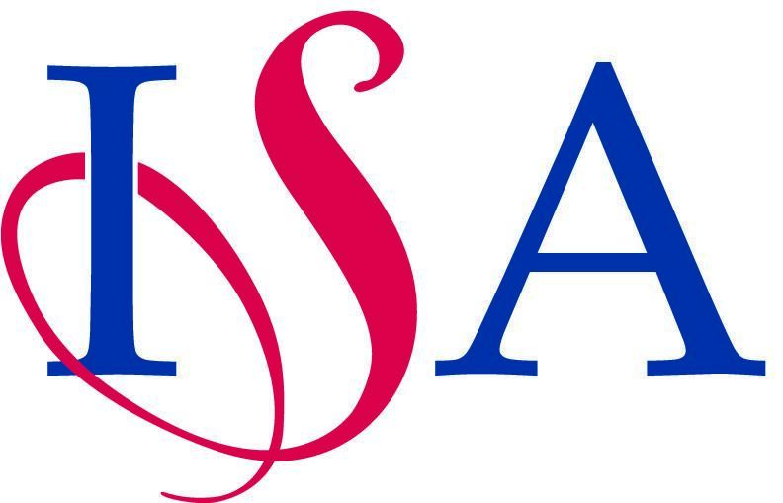

ISA National Gymnastics Team Championships

Entry Form

Adcote School, Little Ness, Shrewsbury SY4 2JY

Sunday 12th May 2024
8.15am – 6.00pm
We wish to enter the ISA National Gymnastics Championships
Ages taken from 1st September 2023
Please note: This is a TEAM event. No individuals allowed.

Name of school
School address
School telephone
School email address
Name of Head Teacher
Teacher i/c Gymnastics
Email
Mobile
Enter team (type ‘Yes’ or ‘No’) | U11 Boys Team U9 Boys Team
Enter team (type ‘Yes’ or ‘No’) | U11 Girls Team U9 Girls Team
Enter Group Sequence  Competition ( type ‘Yes’ or ‘No’) | We would like to enter if this competition goes ahead  U11 Girls Group U9 Girls Group
Over 11 Girls Guest Team  Competition ( type ‘Yes’ or ‘No’) | We would like to enter a team if this guest competition goes ahead  Over 11 Girls Team

Insurance: By entering this event, you confirm that your school has insurance in place to cover pupils, staff, volunteers and anybody else representing your school at this event. ISA and the Organising / Host school does not carry insurance to cover anybody representing your school at this event.

Member of Staff’s Commitment: Once the Closing Date has passed, a number of processes are put into operation and commitments by the host school are made, including financial commitments. Therefore the organisers are put into a very difficult position if any schools withdraw. You are expected to contact the Competition Secretary & Host Organiser personally, before you make a decision, if you really feel that you have no alternative but to withdraw a team.

Photography: Official professional photographer/s will be invited to attend the championships, which by its very nature, is in the public arena. When entering for the event the schools, parents and participants acknowledge this fact, which may result in the recording of his/ her image. The professionals’ equipment is designed to take action shots without flashlight. The contact prints are displayed and can be selected, printed and purchased at the event. If any parents do not wish their child to be photographed, eg. at the Presentation, it is left to individual schools to ensure that the child is removed before team photos are taken. The organisers cannot take responsibility for this. There will be a camera register which has to be signed by all spectators and staff if they intend to take photos on a camera, video or mobile device.

No flash photography is allowed during the competition by spectators as this may distract and is dangerous for the gymnasts.

Please email this entry form asap, and before Friday 16th February 2024 to both:
Competition Secretary: June Walden: chairman@isgagymnastics.org
Host Organiser: Louise Hudson: lhudson@adcoteschool.co.uk
(we may need to operate a ‘first come first served’ system if oversubscribed or if practical, move a section to the day before).
Please note that entries cannot be accepted without a signed Disclaimer form. Scan and send your signed copy of the Disclaimer to both:
Mrs June Walden and Miss Louise Hudson at the addresses above.

Team Names will be required by 16th March 2024

(Names may be changed on the day of the event if necessary)
Privacy Notice
Please be aware of your organisation’s policy with regards to personal data and GDPR. When signing up for an ISA sporting event you agree that we may process your data for administration purposes of the sport and event. We retain personal data only for a legitimate and lawful reason and only for so long as necessary. Currently, we retain all data securely to enable participation selection, personal bests and championship records for future events. Participant data is edited post-event, leaving an initial and surname on results while also removing the date of birth. ISA sports data and results are handled by our partners, Squad in Touch.
If you have any specific queries about our record retention periods or wish to request that your personal data is considered for erasure, please contact isa@isaschools.org.uk. A further list of activities where the data may be used and the organisations with which data may be shared is provided within our privacy statement
----------------------------------------------------------------------------------------------------------------------------
For office purposes only:

Date emailed Entry form

Date Signed Disclaimer received

Attention needed:

Entry accepted

