ISA STEAM Competition - The Egg Drop
Video Link: https://youtu.be/MuLzNvLrqAc

What are we trying to achieve?
We are trying to achieve stopping an egg from breaking when dropped from a height of 2m (or more)
Why did I choose this design?
I decided to not use a parachute because they take too long to open by which time the egg will have fallen and cracked. I used straw as damper because I could not get hold of strong magnets or the correct springs. I have explained this all in my video.
My Design
Instead of using a parachute on top, I turned 4 paper plates upside down and attached them to the top of the container. Inside the container, I put cotton wool all around the egg in the middle. At the bottom, I had 2 paper plates upside down. In the middle of these two paper plates, I put some straws to work as a damper and to hold it all together I used Sellotape. The design of my plates acted as a large canopy which increased air resistance and slowed down the rate at which the egg fell when it was dropped.
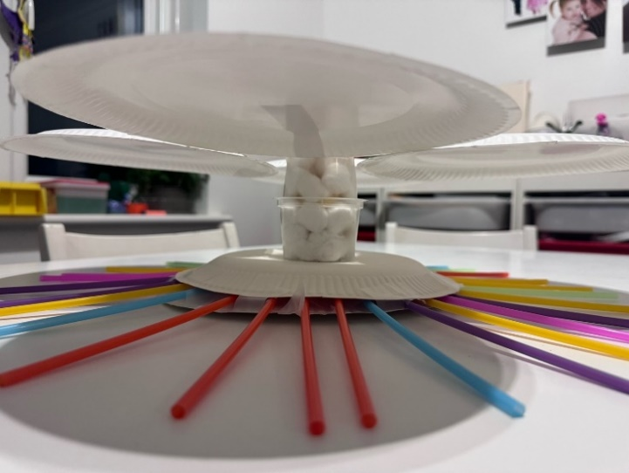
Equipment:
Some straws Some cotton wool
6 paper plates 2 wooden sticks
1 egg 1 plastic container
Sticky tape

My Design Concept
I have used paper plates because they are very light, therefore it would not add that much weight. I turned the paper plates upside down to slow down the drop. Because they are slightly curved, so it will be more air resistance. The Design of the plates also increased the surface area for air to hit my plates which results in an increase in air resistance when my plates are dropped.
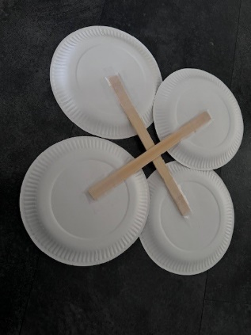
I used straws to work as dampers. I used quite a few because if you only use four or eight it will only be strong enough to hold up the base. Let alone the whole thing, when it has to deal with the impact of hitting the ground.
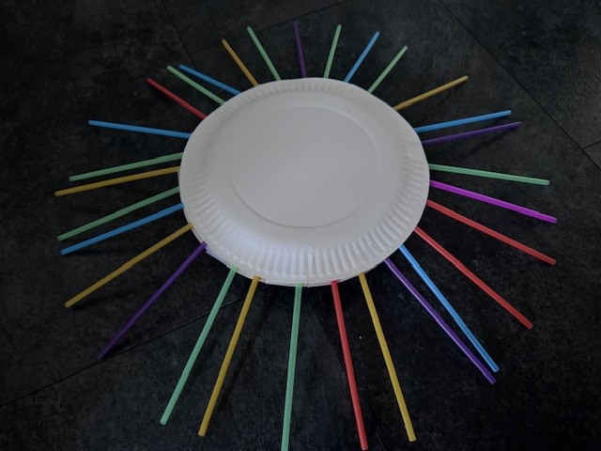
Why did I use what I used?
The reason I used these materials was because I set myself a challenge to use basic home equipment. You do not always need expensive, big and complex solutions to solve something because the more complex it is the more chance it will go wrong. My design is smart, cost effective and very efficient. It was tested in many areas including from a balcony that has a drop of more than 4 metres. Everyone can try and create my design at home, I love inspiring other children to take part in challenges like this as I really love Science. This is why I made sure I used items from home that are readily available and can be bought from any supermarket.
Thank you- I hope you like my design and video as much as I have enjoyed creating it!

