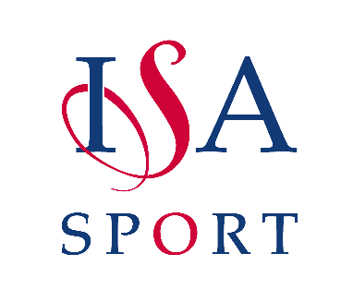

<Event Name>

<Date>

<Venue>

Qualifying Letter

Dear Qualifying School,

Congratulations on your recent success in your area ____________ event. As you have finished in the top ________ we would like to invite you to participate in the ISA National ___________.

The competition will take place on _________ at __________ between _______ (times will be confirmed closer to the date). If you could please confirm your attendance at the event by email as soon as possible to isasport@isaschools.org.uk it would be much appreciated, you will also be manually added to the event via Squad in Touch which is our tournament application.
Please note that you are expected to provide one official per team as it will be required to be a ‘neutral official’ for matches which do not involve your school. You must ensure you have adequate cover for supervision of your team etc (U11/U13 Netball only).

We are also looking for sports leaders who could help with the running of the event, running results from pitches/courts to the results booth etc. If you have any pupils who would be interested in this opportunity, please let us know. They will be provided with refreshments, event tokens, work experience references, and certification etc.

There will be a hoodie printing company present on the day of the finals. If you wish for your team names to be included on the back, we will be sending out a form in the last email correspondence with you.

Further information about the competition will be sent out nearer the time. As a guideline:
- 1 month before event you will be asked to reconfirm attendance
- 1 month before you will receive a parents and coaches information document
- 1-2 weeks before you will receive an event programme electronically

If you have any questions, then please do contact Scott Brand and Emily Ward using the email below
isasport@isaschools.org.uk
Kind regards
ISA National Sport
01799 610 189
07842 767 165 (Scott)
07842 767 163 (Emily)
isasport@isaschools.org.uk

