Autumn 2022
ISA Athlete of the Term - Shortlisted

Congratulations to

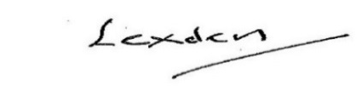  Lord Lexden  President |  | 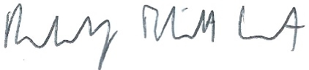  Rudi Eliott Lockhart  CEO

