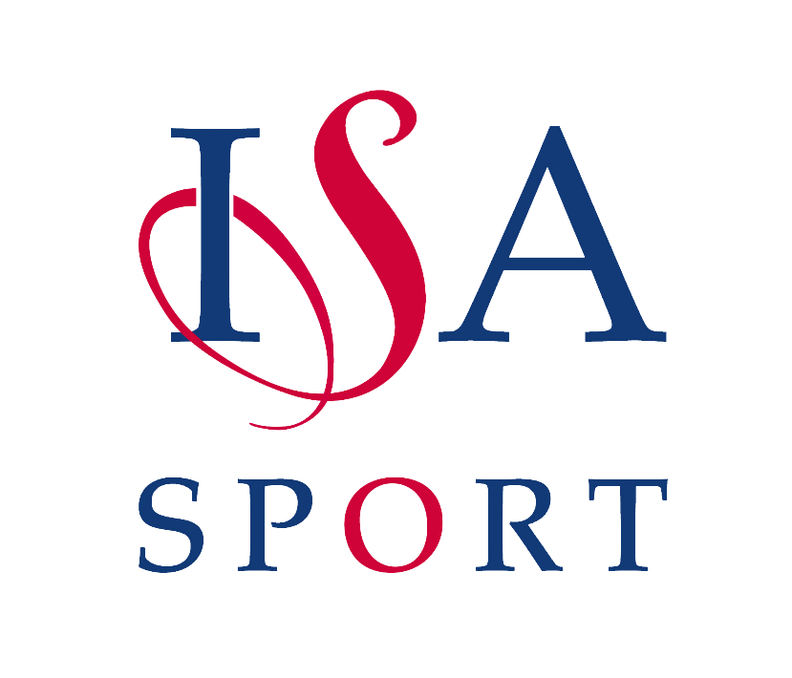

Congratulations to
__________________________________

School: ______________________ ISA Area: ______________
For Outstanding Achievement in
__________________________________
Awarded by:

The Independent Schools Association

Lord Lexden Emily Ward
ISA President ISA National Sports Officer

