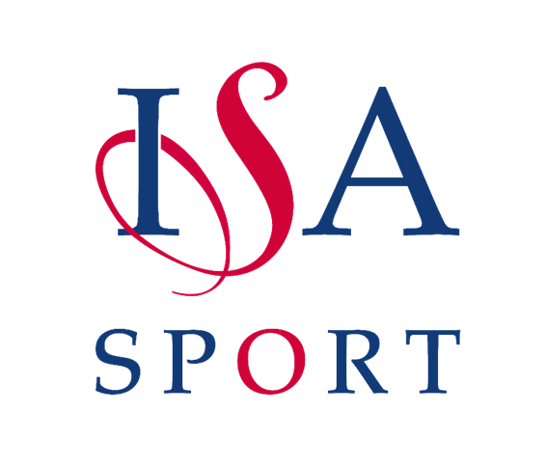

Congratulations to
__________________________________________

School: ______________________ ISA Area: ______________
For Participating in
__________________________________
Awarded by:
The Independent Schools Association
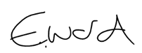
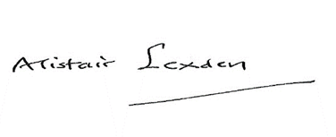

Lord Lexden Emily Ward
ISA President ISA National Sports Officer

