Autumn 2022
ISA Athlete of the Term Winner!

Congratulations to

Lord Lexden  President | 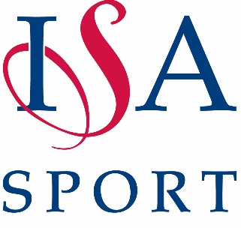 | 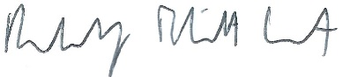  Rudi Eliott Lockhart  CEO

